**Real-Time Communication System**

**Powered By**

**AI For Specially Abled**

*Submitted by*

**ARIHARASUDHAN S (950619104007)**

**SHENBAGA MAHARAJA A (950619104061)**

**ESAKKIDURAI R (950619104018)**

**CHANDRU S (950619104015)**

*For the project*

**HX8001 PROFESSIONAL READYINESS FOR INNOVATION EMPLOYABLITY AND ENTREPRENEURSHIP**

In the department of

**COMPUTER SCIENCE AND ENGINEERING**



**EINSTEIN COLLEGE OF ENGINEEING, TIRUNELVELI-627 012**

**ANNA UNIVERSITY : CHENNAI 600 025**

**NOVEMBER:2022**

**BONAFIED CERTIFICATE**

Certified this Report “**Real-Time Communication System Powered By AI For Specially Abled**”, for the project, is the bonafied work of “ **ARIHARASUDHAN S (950619104007) , SHENBAGA MAHARAJA A (950619104061) , ESAKKIDURAI R (950619104018) , CHANDRU S (950619104015)** who carried out the project work under my supervision. Certified further that to the best of my knowledge the work reported here in does not form part of any other thesis or dissertation on the basis of which a degree or award was co-offerred on the earlier occasion on this or any other candidate.

**SIGNATURE SIGNATURE**

**Dr. M. SURESH THANGAKRISHNAN MRS. S. JEYAMARY**

**HEAD OF THE DEPARTMENT MENTOR**

**COMPUTER SCIENCE AND ENGINEEING COMPUTER SCIENCE AND ENGINEEING**

**EINSTEIN COLLEGE OF ENGINEEING EINSTEIN COLLEGE OF ENGINEERING**

**TIRUNELVELI-12 TIUNELVELI-12**

**ACKNOWLEDGEMENT**

We have successfully completed the project with blessings showered onus by god, the almighty, A project of this nature needs co opreation and support from many for successful completion.

We express our heartfelt thanks to **Mr. A. MATHIVANAN, BE., M.sc, (Agri),** Managing Trustee of Einstein college of Engineering, Tirunelveli, for his mortal support and device.

Our thanks to **Prof. A. AMUTHAVANAN, BE., M.S (USA). B.L,** Chairman of our college for making necessary arrangements to do this project.

Our heartly thanks to **Prof. EZHILVANAN, MBA.,** Secretary of our college for making necessary arrangements to do this project.

We wish to express our gratitude to **Dr. VELAYUTHAM, M.E, Ph.D., FIE.** Principal for the support he provided us to carry out this project successfully.

We are very much thankful to **Dr. M. SURESH THANGAKRISHNAN, M.E**, Head of the Department, Computer Science And Engineering who is always a constant of inspiring us.

We are extend our sincere thanks to all teaching and non-teaching staff members and our family members, friends for their help in completing this project.

**ABSTRACT**

With raising in-depth amalgamation of the Internet and social life, the Internet is looking differently at how people are learning and working, meanwhile opening us to growing serious security attacks. The ways to recognize various network threats, specifically attacks not seen before, is a primary issue that needs to be looked into immediately. The aim of real time communication system powered by Ai for specially abled site URLs is to collect the private information like user’s identity, passwords and online money related exchanges. Phishers use the sites which are visibly and semantically like those of authentic websites. Since the majority of the clients go online to get to the administrations given by the government and money related organizations, there has been a vital increment in phishing threats and attacks since some years. As technology is growing, phishing methods have started to progress briskly and this should be avoided by making use of anti-phishing techniques to detect phishing. Machine learning is a authoritative tool that can be used to aim against phishing assaults. There are several methods or approaches to identify phishing websites. The machine learning approaches to detect phishing websites have been proposed earlier and have been implemented. The central aim of this project is to implement the system with high efficiency, accuracy and cost effectively. That is been achieved. The project is implemented using 4 machine learning supervised classification models. The four classification models are K-Nearest Neighbor, Kernel Support vector machine, decision tree and random forest classifier. It was established that the Random forest classifier provides best accuracy for the selected dataset and gives an accuracy score of 96.82%.

**TABLE OF CONTENTS**

**CHAPTER NO TITLE PAGE NO**

**ABSTRACT**

**LIST OF FIGURES**

**LIST OF TABLES**

**1 INTRODUCTION**

1.1 Project Overview

1.2 Purpose

**2 LITERATURE SURVEY**

2.1 Existing problem

2.2 References

2.3 Problem Statement Definition

**3 IDEATION & PROPOSED SOLUTION**

3.1 Empathy Map Canvas

3.2 Ideation & Brainstorming

3.3 Proposed Solution

3.4 Problem Solution fit

**4. REQUIREMENT ANALYSIS**

4.1 Functional requirement

4.2 Non-Functional requirements

**5. PROJECT DESIGN**

5.1 Data Flow Diagrams

5.2 Solution & Technical Architecture

5.3 User Stories

**6. PROJECT PLANNING & SCHEDULING**

6.1 Sprint Planning & Estimation

6.2 Sprint Delivery Schedule

6.3 Burndown Chart

**7. CODING & SOLUTIONING**

7.1 Feature 1

7.2 Feature 2

**8. TESTING**

8.1 Test Cases

8.2 User Acceptance Testing

**9. RESULTS**

9.1 Performance Metrics

**10.**  **ADVANTAGES & DISADVANTAGES**

**11. CONCLUSION**

**12. FUTURE SCOPE**

**13. APPENDIX Source Code GitHub & Project**

**Demo Link**

**LIST OF FIGURES**

**FIG.NO FIG.NAME PAGE.NO**

**3.1.1 Empathy map canvas**

**3.2.2 Brain Storming**

**3.2.3 Individual Ideas**

**5.1.1 Data flow diagrams**

**5.2.1 Technical Architecture**

**5.3.1 User Stories**

**6.3.1 Burndown Chart**

**LIST OF TABLES**

**TAB.NO TAB.NAME TAB.PAGE**

**3.3.1 Proposal Solution**

**Non Functional Requirements**

**Sprint Planning and Estimation**

**Sprint Delivery Schedule**

**CHAPTER 1**

**1. INTRODUCTION**

* 1. **Project Overview**

In our society, we have people with disabilities. The technology is developing day by day but no significant developments are undertaken for the betterment of these people. Communications between deaf-mute and a normal person has always been a challenging task. It is very difficult for mute people to convey their message to normal people. Since normal people are not trained on hand sign language. In emergency times conveying their message is very difficult. The human hand has remained a popular choice to convey information in situations where other forms like speech cannot be used. Voice Conversion System with Hand Gesture Recognition and translation will be very useful to have a proper conversation between a normal person and an impaired person in any language.

The project aims to develop a system that converts the sign language into a human hearing voice in the desired language to convey a message to normal people, as well as convert speech into understandable sign language for the deaf and dumb. We are making use of a convolution neural network to create a model that is trained on different hand gestures. An app is built which uses this model. This app enables deaf and dumb people to convey their information using signs which get converted to human-understandable language and speech is given as output.

* 1. **PURPOSE**

The real time communication system powered by Ai for specially abled persons. The project aims to develop an Ai model that converts sign language into a speech that can be understood by normal people.

**CHAPTER 2**

**2. LITERATURE SURVEY**

**2.1 EXISTING PROBLEM**

Research in the sign language system has two well-known approaches are Image processing and Data glove. The image processing technique using the camera to capture the image/video. Analysis the data with static images and recognize the image using algorithms and produce sentences in the display, vision based sign language recognition system mainly follows the algorithms are Hidden Markov Mode (HMM), Artificial Neural Networks (ANN) and Sum of Absolute Difference (SAD) Algorithm use to extract the image and eliminate the unwanted background noise. The main drawback of vision based sign language recognition system image acquisition process has many environmental apprehensions such as the place of the camera, background condition and lightning sensitivity. Camera place to focus the spot that capture maximum achievable hand movements, higher resolution camera take up more computation time and occupy more memory space. User always need camera forever and cannot implement in public place. Another research approach is a sign language recognition system using a data glove. User need to wear glove consist of flex sensor and motion tracker. Data are directly obtained from each sensor depends upon finger flexures and computer analysis sensor data with static data to produce sentences. It’s using neural network to improve the performance of the system. The main advantage of this approach less computational time and fast response in real time applications. It is portable device and cost of the device also low.

Another approach using a portable Accelerometer (ACC) and Surface Electro Myogram (EMG) sensors used to measure the hand gesture. ACC used to capture movement information of hand and Arms. EMG sensor placed, it generates different sign gesture. Sensor output signals are fed to the computer process to recognize the hand gesture and produce speech/text. But none of the above methods provide users with natural interaction. This proposed system will be capable of performing the conversation without any wearable device instead using the human motion and gesture recognition.

**2.2 REFERENCES**

Fels Glove Talk focused on a gesture-to-speech interface. Moreover, a multilayer perceptron model was used in Beale and Edward’s posture recognizer to classify sensed data into five postures in ASL. To help people with disabilities, Newby worked on the recognition of the letters and numbers of the ASL manual alphabet based upon statistical similarity. A simplified method, using approximate spline, was proposed by Watson. Gestures are represented by a sequence of critical points (local minima and maxima) of the motion of the hand and wrist. This approach is more flexible in matching a gesture both spatially and temporally and thus reduces the computational requirement.

Starner and Pentland’s American Sign Language system could recognize short sentences of American Sign Language (ASL) with 40 vocabularies, each was attached with its part of speech, which greatly reduced the computational complexity. The feature vector was fed to a hidden Markov model (HMM) for recognition of the signed words. This system gracefully integrated a useful concept in computational linguistics into gesture recognition. Furthermore, Nam’s system tried to recognize hand movement patterns. A HMM-based method for recognizing the space-time hand movement pattern was proposed, and 10 kinds of movement primes could be recognized successfully.

Liang and ouhyoung proposed a sign language recognition system using hidden Markov mode land integrated statistical approach used in computational linguistics. Real-time Continuous Gesture Recognition System for Sign Language by Rung Huei Liang , Ming Ouhyoung intended to recognize large set of vocabularies in a sign language by recognizing constructive postures and context information. The system uses position, orientation, and motion model, in addition to the posture model, are implemented to enhance the performance of the system.

Noor Saliza Mohd Salleh et al. have presented a research progress and findings on techniques and algorithms for hand detection as it will be used as an input for gesture recognition process. Rini Akmelia et al. have develop real time Malaysian sign language translation using colour segmentation and neural network where it achieved the recognition rate of over 90%.

***2.3* PROBLEM SOLUTION DEFINITION**

The project aims to develop a system that converts the sign language into a human hearing voice in the desired language to convey a message to normal people, as well as convert speech into understandable sign language for the deaf and dumb. We are making use of a convolution neural network to create a model that is trained on different hand gestures. An app is built which uses this model. This app enables deaf and dumb people to convey their information using signs which get converted to human-understandable language and speech is given as output.

**CHAPTER 3**

**3. IDEATOIN & PRPOSED SOLUTION**

In this activity we are prepared the empathy map canvas to capture the user Pains & Gains, brainstorming, problem solution fit and proposed solution based on the feasibility & importance.

**3.1 EMPATHY MAP CANVAS**

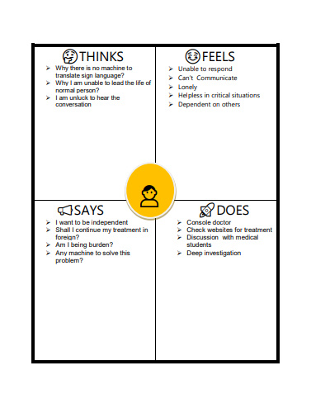

**Fig 3.1.1 Empathy Map Canvas**

**3.2 IDEATION & BRAINSTROMING**

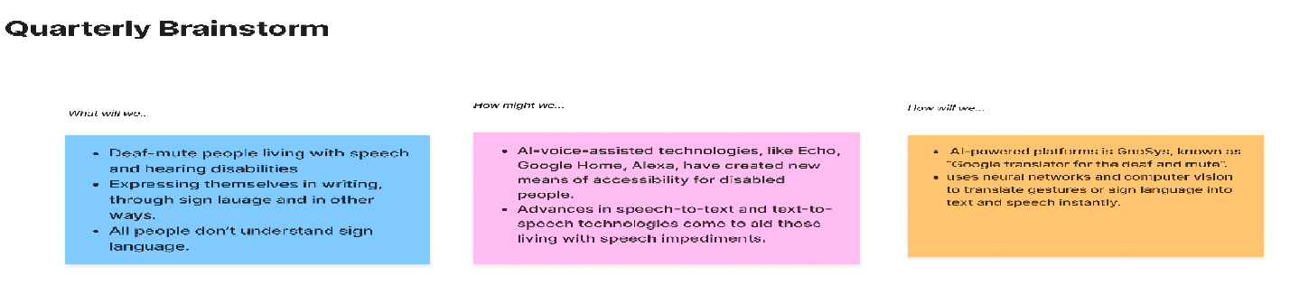

**Fig 3.2.1 Quarterly Brainstorm**

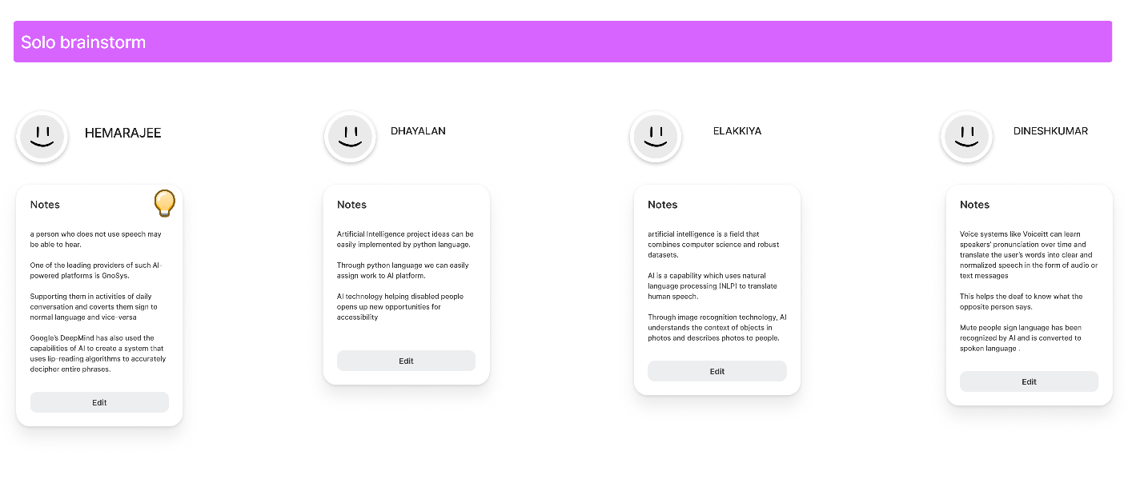

**Fig 3.2.2 Solo Brainstorm**

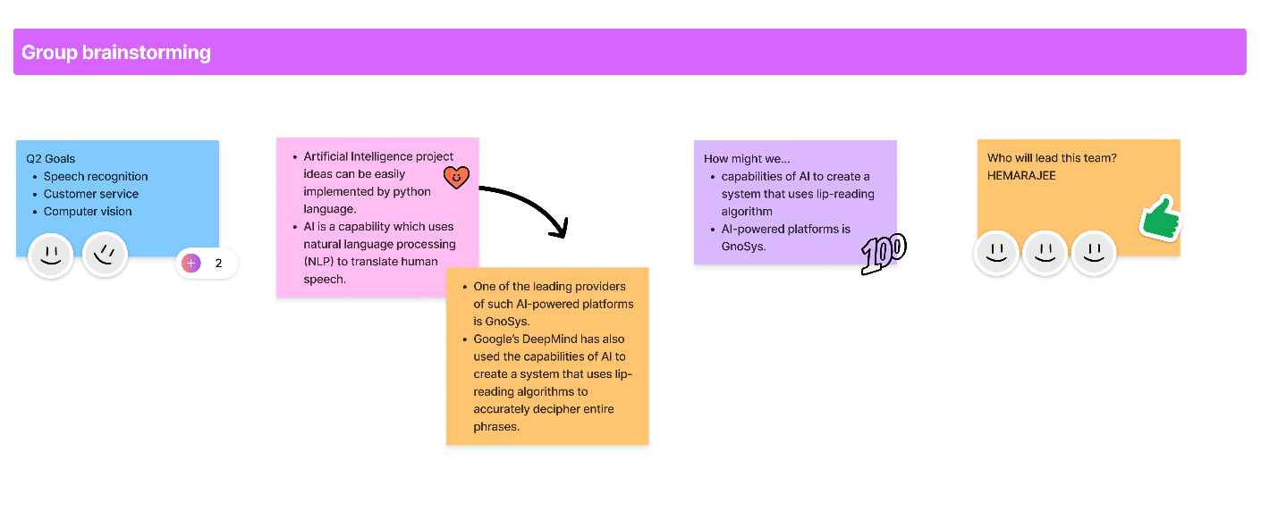

**Fig 3.2.3 Group Brainstorming**

**3.3 PROPOSED SOLUTION**

Project team shall fill the following information in proposed solution template.

**Below** **(Table: Proposed solution 3.3.1)**

|  |  |  |
| --- | --- | --- |
| **S.No.** | **Parameter** | **Description** |
| 1. | Problem Statement (Problem to be solved) | Accumulated tension can lead to high blood pressure, fertility problems, insomnia, and an elevated risk of heart attack, among other health issues for Disability person. The latest Fitbit Sense smart watch has a strong focus on stress- busting and it detect even the single movement of Disability person by using movement sensor |
| 2. | Idea / Solution description | A convenient feature of many smartwatches is their heart rate monitor, movement sensing and voice monitoring or guiding. You may want to check your heart rate regularly for a variety of reasons, from improving your athletic performance to managing your stress levels to tracking your heart health. |
| 3. | Novelty / Uniqueness | Movement sensor, Heartbeat monitoring sensor, Siri, Connecting with phone(call) to family members. |
| 4. | Social Impact / Customer Satisfaction | Security, Quality of Services, Quick process, Water proof, Bluetooth connection, Automatic detecting sensors (monitor and movement). |
| 5. | Business Model (Revenue Model) | • Smart watch  • Sensors |
| 6. | Scalability of the Solution | To achieve accumulated tension can lead to high blood pressure, fertility problems, insomnia, and an elevated risk of heart attack, among other health issues for Disability person. The latest fit bit Sense smart watch has a strong focus on stress- busting and it detect even the single movement of Disability person by using movement sensor. |

**3.4 PROBLEM SOLUTION FIT**

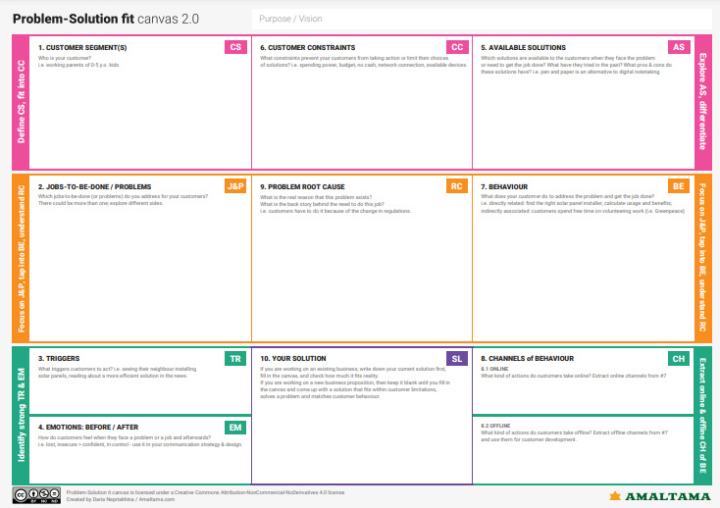

**CHAPTER 4**

**4. REQUIREMENT ANALYSIS**

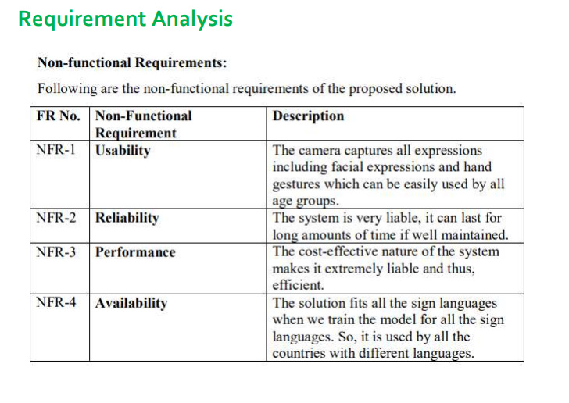

**(Table Functional requirements 4.1.1)**

Reliability , Maintainability , Performance , Portability , Scalability , Flexibility

**CHAPTER 5**

**5. PROJECT DESIGN**

5.1 Data flow diagram

5.2 Solution and technical architecture

5.3 User Stories

**5.1 Data Flow Diagram**

A Data Flow Diagram (DFD) is a traditional visual representation of the information flows within a system. A neat and clear DFD can depict the right amount of the system requirement graphically. It shows how data enters and leaves the system, what changes the information, and where data is stored.

**Architecture:**

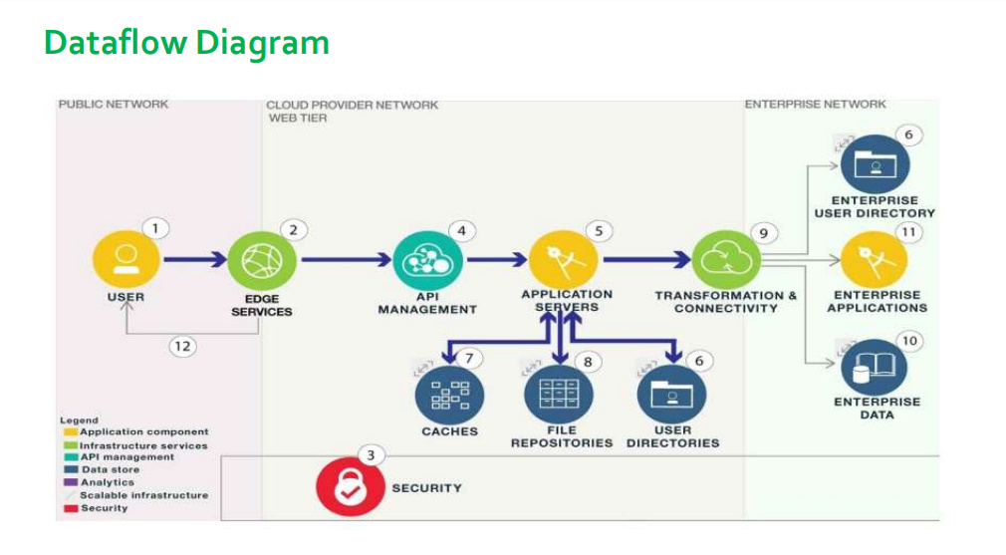

**Fig 5.1.1 Data Flow Diagrams**

**5.2 SOLUTION & TECHNICAL ARCHITECTURE**

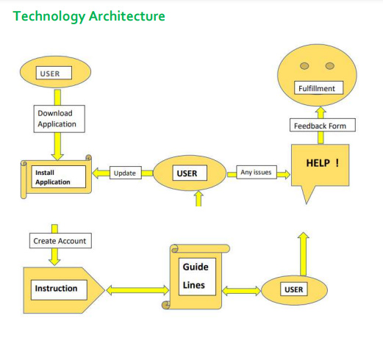

**Fig Technical Architecture 5.2.1**

**5.3 User Stories**

Use the below template to list all the user stories for the product.

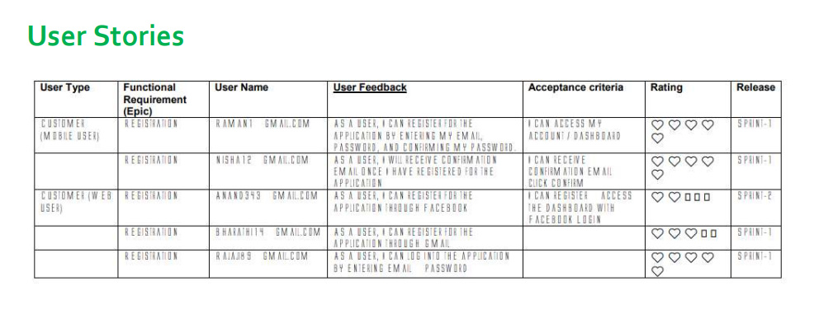

**CHAPTER 6**

**6. PROJECT PLANNING & SCHEDULING**

**6.1 SPRINT PLANNINGA AND ESTIMATION**

|  |  |  |  |
| --- | --- | --- | --- |
| S.NO | ACTIVITY TITLE | ACTIVITY  DESCRIPTION | DURATION |
| 1 | Project preparation | Assign team members, Create repository in the Git hub, download rocket-chat essentials and join  respective project channel. | 1 WEEK |
| 2 | Attend class | Attend sessions on IBM, team leader assign task to each  member of the project, attend quit, submit assignment . | 1 WEEK |
| 3 | Working on different phases of project | Ideation phase-literature survey, Project design phase I-proposed solution, solution architecture, project design phase II-customer journey, data flow, technical architecture, planning phase- milestones, tasks, sprint  schedule. | 4-WEEK |
| 4 | Developing project | Develop the code, test and push it to  GitHub, clarify queries. | 2-WEEK |
| 5 | Budget and scope of project | Analyze and making the project budget and  discuss with team for budget prediction. | 1 WEEK |

**Table Sprint planning and estimation 6.1.1**

**6.2 SPRINT DELIVERY SCHEDULE**

Use the below template to create product back log and sprint schedule

|  |  |  |  |  |  |  |
| --- | --- | --- | --- | --- | --- | --- |
| **Sprint** | **Function al Requirement( Epic)** | **UserStoryNumber** | **UserStory/Task** | **Story Points** | **Priority** | **TeamMembers** |
| **Sprint-1** | Data Collection | USN-1 | Collect Dataset. | 9 | High | Ariharasudhan S |
| **Sprint-1** |  | USN-2 | Image preprocessing | 8 | Medium | Shenbaga Maharaja A |
| **Sprint-2** | Model Building | USN-3 | Import the required libraries, add  The necessary layer sand compile the model | 10 | High | Ariharasudhan S |
| **Sprint-2** |  | USN-4 | Training the image classification model Using CNN | 7 | Medium | Esakkidurai R |
| **Sprint-3** | Training and Testing | USN-5 | Training the model and testing the model sprint performance | 9 | High | Shenbaga Maharaja A |
| **Sprint-4** | Implementation of the application | USN-6 | Converting the input signal mages into English alphabets | 8 | Medium | Chandru S |

**Project Tracker, Velocity & Burndown Chart:(4Marks)**

|  |  |  |  |  |  |  |
| --- | --- | --- | --- | --- | --- | --- |
| **Sprint** | **Total Story Points** | **Duration** | **Sprint Start Date** | **Sprint End Date (Planned)** | **Story**  **Points Completed**  **(a son Planned End Date)** | **Sprint Release Date (Actual)** |
| **Sprint-1** | 10 | 4Days | 01Nov2022 | 04Nov2022 | 8 | 29Oct2022 |
| **Sprint-2** | 10 | 5Days | 05Nov2022 | 09Nov2022 | 5 | 04Nov2022 |
| **Sprint-3** | 10 | 5Days | 10Nov2022 | 14Nov2022 | 7 | 11Nov2022 |
| **Sprint-4** | 10 | 5Days | 15Nov2022 | 19Nov2022 | 5 | 18Nov2022 |

**Velocity:**

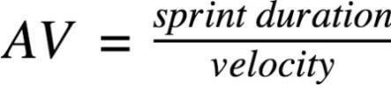

**AV =7/10=0.7**

**6.3 SPRINT BURNDOWN CHART**

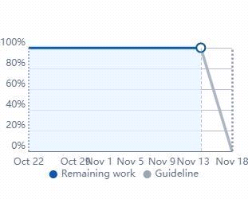

**CHAPTER 7**

**7. CODING & SOLUTIONING**

**(Explain the features added in the project along with code)**

**7.1 FEATURE 1**

**Software Requirement Specification (SRS)**

**PANDAS**

Pandas is an open-source, BSD-authorized Python library giving elite, simple to-utilize information structures and information examination instruments for the Python programming language. Python with Pandas is utilized in a wide scope of fields including scholastic and business areas including money, financial matters, Statistics, examination, and so on. In this instructional exercise, we will get familiar with the different highlights of Python Pandas and how to utilize them practically speaking. This instructional exercise has been set up for the individuals who try to become familiar with the essentials and different elements of Pandas. It will be explicitly valuable for individuals working with information purging and examination. In the wake of finishing this instructional exercise, you will wind up at a moderate dimension of ability from where you can take yourself to more elevated amounts of skill. You ought to have a fundamental comprehension of Computer Programming phrasings. A fundamental comprehension of any of the programming dialects is an or more. Pandas library utilizes the vast majority of the functionalities of NumPy. It is recommended that you experience our instructional exercise on NumPy before continuing with this instructional exercise. 2.4.5 ANACONDA Anaconda constrictor is bundle director. Jupyter is an introduction layer.Boa constrictor endeavors to explain the reliance damnation in python—where distinctive tasks have diverse reliance variants—in order to not influence distinctive venture conditions to require diverse adaptations, which may meddle with one another. Jupyter endeavors to fathom the issue of reproducibility in investigation by empowering an iterative and hands-on way to deal with clarifying and imagining code; by utilizing rich content documentations joined with visual portrayals, in a solitary arrangement. Boa constrictor is like pyenv, venv and minconda; it's intended to accomplish a python situation that is 100% reproducible on another condition, autonomous of whatever different forms of a task's conditions are accessible. It's somewhat like Docker, however limited to the Python biological system. Jupyter is an astounding introduction device for expository work; where you can display code in "squares," joins with rich content depictions among squares, and the consideration of organized yield from the squares, and charts created in an all around planned issue by method for another square's code. Jupyter is extraordinarily great in expository work to guarantee reproducibility in somebody's exploration, so anybody can return numerous months after the fact and outwardly comprehend what somebody attempted to clarify, and see precisely which code drove which representation and end. Regularly in diagnostic work you will finish up with huge amounts of half-completed note pads clarifying Proof-of-Concept thoughts, of which most won't lead anyplace at first. A portion of these introductions may months after the fact—or even years after the fact— present an establishment to work from for another issue.

**PYTHON**

Python is a translated, object-arranged, abnormal state programming language with dynamic semantics. Its abnormal state worked in information structures, joined with dynamic composing and dynamic authoritative, make it appealing for Rapid Application Development, just as for use as a scripting or paste language to interface existing segments together. Python's basic, simple to learn language structure underlines intelligibility and hence decreases the expense of program support. Python underpins modules and bundles, which empowers program seclusion and code reuse. The Python translator and the broad standard library are accessible in source or parallel structure without charge for every single significant stage, and can be openly appropriated. Frequently, software engineers begin to look all starry eyed at Python on account of the expanded efficiency it gives. Since there is no aggregation step, the alter test-troubleshoot cycle is staggeringly quick.

Troubleshooting Python programs is simple: a bug or awful information will never cause a division blame. Rather, when the mediator finds a blunder, it raises a special case. At the point when the program doesn't get the special case, the translator prints a stack follow. A source level debugger permits assessment of nearby and worldwide factors, assessment of discretionary articulations, setting breakpoints, venturing through the code a line at any given moment, etc. The debugger is written in Python itself, vouching for Python's contemplative power. Then again, frequently the speediest method to troubleshoot a program is to add a couple of print proclamations to the source: the quick alter testinvestigate cycle makes this straightforward methodology successful. Python is an item situated, abnormal state programming language with incorporated unique semantics essentially for web and application improvement. It is amazingly alluring in the field of Rapid Application Development since it offers dynamic composing and dynamic restricting alternatives. Python is generally basic, so it's anything but difficult to learn since it requires a one of a kind language structure that centers around coherence. Designers can peruse and interpret Python code a lot simpler than different dialects. Thusly, this decreases the expense of program upkeep and improvement since it enables groups to work cooperatively without huge language and experience obstructions. Moreover, Python underpins the utilization of modules and bundles, which implies that projects can be planned in a secluded style and code can be reused over an assortment of tasks. When you've built up a module or bundle you need, it very well may be scaled for use in different tasks, and it's anything but difficult to import or fare these modules. A standout amongst the most encouraging advantages of Python is that both the standard library and the mediator are accessible for nothing out of pocket, in both parallel and source structure. There is no restrictiveness either, as Python and all the important instruments are accessible on every single real stage. In this way, it is a tempting alternative for designers who would prefer not to stress over paying high improvement costs.

**7.2 FEATURE 2**

**HTML HOME PAGE**

**<!DOCTYPE html>**

**<html lang="en">**

**<head>**

**<meta charset="utf-8">**

**<meta name="viewport" content="width=device-width, initial-scale=1.0, shrink-to-fit=no">**

**<title>SmartBridge_WebApp_VideoTemplate</title>**

**<link rel="stylesheet" href="https://cdn.jsdelivr.net/npm/bootstrap@5.1.3/dist/css/bootstrap.min.css">**

**<link rel="stylesheet" href="https://use.fontawesome.com/releases/v5.12.0/css/all.css">**

**<link rel="stylesheet" href="assets/css/Banner-Heading-Image.css">**

**<link rel="stylesheet" href="assets/css/Navbar-Centered-Brand.css">**

**<link rel="stylesheet" href="assets/css/styles.css">**

**</head>**

**<body style="background: rgb(39,43,48);">**

**<nav class="navbar navbar-light navbar-expand-md py-3" style="background: #212529;">**

**<div class="container">**

**<div></div><a class="navbar-brand d-flex align-items-center" href="#"><span**

**class="bs-icon-sm bs-icon-rounded bs-icon-primary d-flex justify-content-center align-items-center me-2 bs-icon"><i**

**class="fas fa-flask"></i></span><span style="color: rgb(255,255,255);">Real-Time Communication**

**System Powered By AI&nbsp;For Specially Abled</span></a>**

**<div></div>**

**</div>**

**</nav>**

**<section>**

**<div class="d-flex flex-column justify-content-center align-items-center">**

**<div class="d-flex flex-column justify-content-center align-items-center" id="div-video-feed"**

**style="width: 640px;height: 480px;margin: 10px;min-height: 480px;min-width: 640px;border-radius: 10px;border: 4px dashed rgb(255,255,255) ;">**

**<img src="{{ url_for('video_feed') }}" style="width: 100%;height: 100%;color: rgb(255,255,255);text-align: center;font-size: 20px;"**

**alt="Camera Access Not Provided!">**

**</div>**

**</div>**

**<div class="d-flex flex-column justify-content-center align-items-center" style="margin-bottom: 10px;"><button**

**class="btn btn-info" type="button" data-bs-target="#modal-1" data-bs-toggle="modal">Quick Reference**

**-<strong> ASL Alphabets</strong></button></div>**

**</section>**

**<section>**

**<div class="container">**

**<div class="accordion text-white" role="tablist" id="accordion-1">**

**<div class="accordion-item" style="background: rgb(33,37,41);">**

**<h2 class="accordion-header" role="tab"><button class="accordion-button" data-bs-toggle="collapse"**

**data-bs-target="#accordion-1 .item-1" aria-expanded="true"**

**aria-controls="accordion-1 .item-1"**

**style="background: rgb(39,43,48);color: rgb(255,255,255);">About The Project</button></h2>**

**<div class="accordion-collapse collapse show item-1" role="tabpanel" data-bs-parent="#accordion-1">**

**<div class="accordion-body">**

**<p class="mb-0">Artificial Intelligence has made it possible to handle our daily activities**

**in new and simpler ways. With the ability to automate tasks that normally require human**

**intelligence, such as speech and voice recognition, visual perception, predictive text**

**functionality, decision-making, and a variety of other tasks, AI can assist people with**

**disabilities by significantly improving their ability to get around and participate in**

**daily activities.<br><br>Currently, Sign Recognition is available <strong>only for**

**alphabets A-I</strong> and not for J-Z, since J-Z alphabets also require Gesture**

**Recognition for them to be able to be predicted correctly to a certain degree of**

**accuracy.</p>**

**</div>**

**</div>**

**</div>**

**<div class="accordion-item" style="background: rgb(33,37,41);">**

**<h2 class="accordion-header" role="tab"><button class="accordion-button collapsed"**

**data-bs-toggle="collapse" data-bs-target="#accordion-1 .item-2" aria-expanded="false"**

**aria-controls="accordion-1 .item-2"**

**style="background: rgb(39,43,48);color: rgb(231,241,255);">Developed By</button></h2>**

**<div class="accordion-collapse collapse item-2" role="tabpanel" data-bs-parent="#accordion-1">**

**<div class="accordion-body">**

**<p class="mb-0">Students at APEC**

**Program.<br><br>1. <strong>KEERTHANA</strong> 420419104029<br>2.**

**<strong>KAVIYA</strong>420419104028<br>3. <strong>YUVASHREE</strong> 420419104061<br>4. <strong>SUMITHRA</strong> 420419104305<br>**

**</p>**

**</div>**

**</div>**

**</div>**

**</div>**

**</div>**

**</section>**

**<div class="modal fade" role="dialog" tabindex="-1" id="modal-1">**

**<div class="modal-dialog" role="document">**

**<div class="modal-content">**

**<div class="modal-header">**

**<h4 class="modal-title">American Sign Language - Alphabets</h4><button type="button"**

**class="btn-close" data-bs-dismiss="modal" aria-label="Close"></button>**

**</div>**

**<div class="modal-body"><img src="{{ url_for('static', filename='img/ASL_Alphabets.png') }}" width="100%"></div>**

**<div class="modal-footer"><button class="btn btn-secondary" type="button"**

**data-bs-dismiss="modal">Close</button></div>**

**</div>**

**</div>**

**</div>**

**<script src="https://cdn.jsdelivr.net/npm/bootstrap@5.1.3/dist/js/bootstrap.bundle.min.js"></script>**

**</body>**

**</html>**

**NUMPY**

* NumPy is an open-source library in Python that provides support in mathematical, scientific, engineering, and data science programming.
* To perform large mathematical operations and statistical operations Numpy is an incredible library.
* Numpy is basically a simple programming language that works superbly well for the multi-dimensional arrays and matrices multiplication.
* In 2005, Numpy was created by Travis Oliphant and as it is open-source so anyone can access it freely.
* Numpy is a great tool for any scientific project and it also contains a powerful n-dimensional array object.
* NumPy Library is written partially in Python and the parts of NumPy that require fast computation are written in C or C++.
* Where is Numpy used?
* Below we have some usecases where NumPy is effective to use:
* Numpy is very useful in performing operations that are related to linear algebra and for its handling of random numbers.
* NumPy can efficiently implement multi-dimensional array objects (that are in the form of rows and columns).
* Numpy works efficiently with reshaping of matrices, random numbers, and Fourier transforms, etc.
* Numpy was designed for scientific computation.
* One thing is important to note here that TensorFlow and Scikit learn also uses NumPy array to compute the matrix multiplication in their back end
* Why to use Numpy in Python?
* Because, in Python, Lists are used in order to serve the purpose of the array but lists are very slow to process. Hence we use Numpy in Python because it provides an array object that is up to 50x faster than traditional Python lists. And Python has other modules too, which makes data analysis and presentation very easy. So Numpy library is used with Python along with other Python libraries like Matplotlib, Scikit Learn, etc for AI/ML and Data analysis purposes.
* In NumPy, the array object is commonly known as ndarray. Numpy provides a lot of supporting functions for performing operations on its array object and with these functions, working with ndarray becomes very easy.
* Also, the NumPy arrays are more compact than Python Lists in terms of the size.
* NumPy uses much less memory in order to store data and it provides an easy mechanism of specifying the data types. Thus code can be optimized easily.
* Now you must be thinking, that how NumPy works faster than lists. Don't worry, we have an answer for your question.
* NumPy arrays are mainly stored at one continuous place in memory contrary to lists. Thus you can access and manipulate them very efficiently and this behavior is commonly known as locality of reference. Due to this reason, Numpy is faster than lists. Numpy is optimized to work with latest CPU architecture.
* Like we mentioned above, NumPy is also used along with packages like SciPy (Scientific Python) and Matplotlib (plotting library in python).
* This combination is mainly a replacement for MatLab(which is a popular platform for technical computing). Also, Python is an alternative to MatLab and is now seen as a modern and complete programming language.

**CHAPTER 8**

**8. TESTING**

**8.1 Test Cases**

Testing is most important in there real time communication system powered by Ai for specially abled people , In the real time there are many new types of communication are arises and small scale and large scale industries and peoples who are suffering by this attack. so , the dataset need to update frequently

And also , its not a one way communication to the user while using our product he can able to communicate with our team by the "Help Page" where he can able to mention their problems and also send a complaint or a problem with our team.

Software testing is a critical element of software quality assurance and represents the ultimate review of specification, design and coding. In fact, testing is the one step in the software engineering process that could be viewed as destructive rather than constructive.

A strategy for software testing integrates software test case design methods into a well-planned series of steps that result in the successful construction of software. Testing is the set of activities that can be planned in advance and conducted systematically. The underlying motivation of program testing is to affirm software quality with methods that can economically and effectively apply to both strategic to both large and small-scale systems

**8.2 USER ACCEPTANCE TESTING**

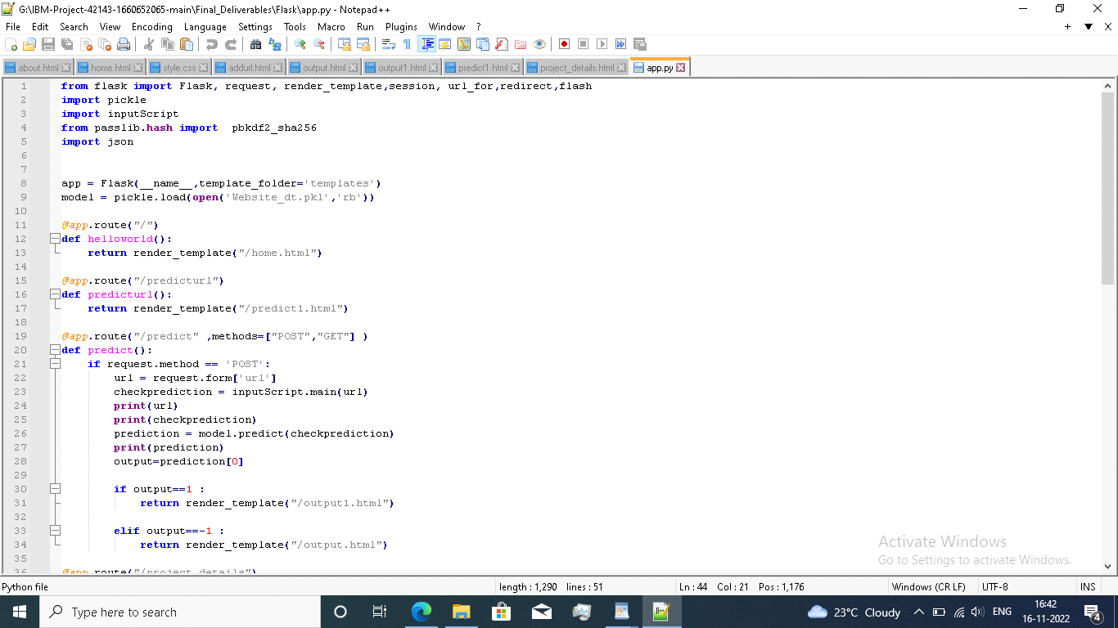

**CHAPTER 9**

**9. RESULT**

**9.1 Performance Metrics**

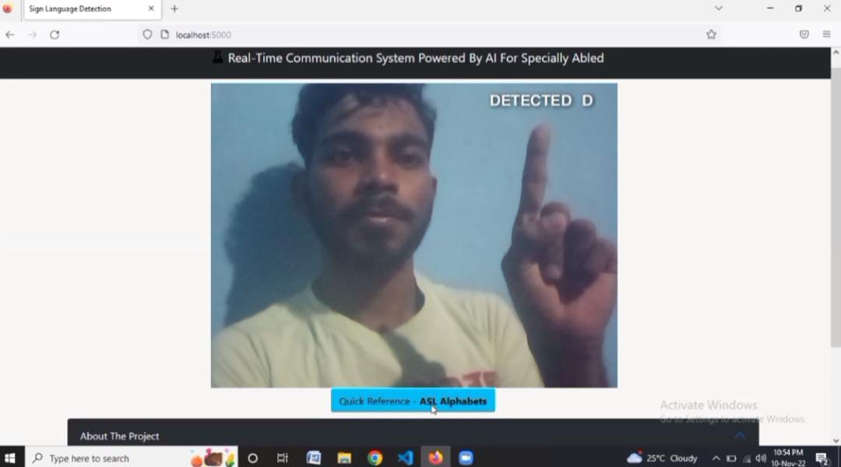

**CHAPTER 10**

**10. ADVANTAGES AND DISADVANTAGES**

**Advantages**

* This system can be portable. i.e., it can be accessed by anyone from anywhere
* User Friendliness is the main criteria
* It works faster due to the incorporated facilities of Flask
* It is much social-helping application
* It is scalable due to the incorporated web technology

**Disadvantages**

* If Internet connection fails, this system won’t work.
* All websites related data will be stored in one place.
* Process takes longer time than normal communication.
* It requires active internet connection else error may occur

**CHAPTER 11**

**11. CONCLUSION**

He project aims to develop a system that converts the sign language into a human hearing voice in the desired language to convey a message to normal people, as well as convert speech into understandable sign language for the deaf and dumb. We are making use of a convolution neural network to create a model that is trained on different hand gestures. An app is built which uses this model. This app enables deaf and dumb people to convey their information using signs which get converted to human-understandable language and speech is given as output.

**CHAPTER 12**

**12. FUTURE SCOPE**

Further work can be done to enhance the model by using ensembling models to get greater accuracy score. Ensemble methods is a ML technique that combines many base models to generate an optimal predictive model. Further reaching future work would be combining multiple classifiers, trained on different aspects of the same training set, into a single classifier that may provide a more robust prediction than any of the single classifiers on their own. Looking even further out, the methodology needs to be evaluated on how it might handle collection growth. The collections will ideally grow incrementally over time so there will need to be a way to apply a classifier incrementally to the new data, but also potentially have this classifier receive feedback that might modify it over time.

**CHAPTER 13**

**13. APPENDIX**

**Source code**

**Github & Project Demo link**

**13.1 SOURCE CODE**

**13.1.1 Python Flask Coding**

**from flask import Flask, Response, render_template**

**from camera import Video**

**app = Flask(__name__)**

**@app.route('/')**

**def index():**

**return render_template('index.html')**

**def gen(camera):**

**while True:**

**frame = camera.get_frame()**

**yield(b'--frame\r\n'**

**b'Content-Type: image/jpeg\r\n\r\n' + frame +**

**b'\r\n\r\n')**

**@app.route('/video_feed')**

**def video_feed():**

**video = Video()**

**return Response(gen(video), mimetype='multipart/x-mixed-replace; boundary = frame')**

**if __name__ == '__main__':**

**app.run()**

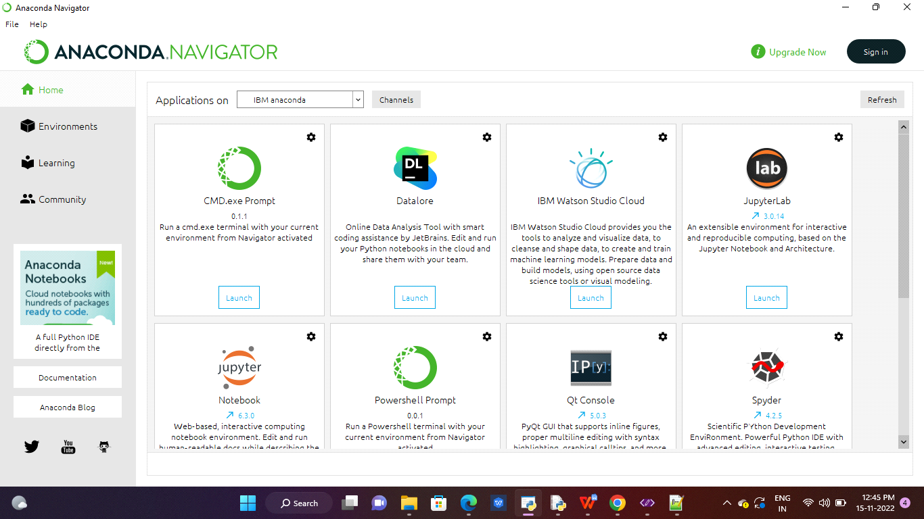

**Fig 13.1.1.1 show the import in computer**

**GITHUB & PROJECT DEMO LINK**

<https://github.com/IBM-EPBL/IBM-Project-45799-1660732369>